REGULATION (EU) 2019/1009 OF THE EUROPEAN PARLIAMENT

AND OF THE COUNCIL

of 5 June 2019

laying down rules on the making available on the market of EU fertilising products and amending Regulations (EC) No 1069/2009 and (EC) No
1107/2009 and repealing Regulation (EC) No 2003/2003
CONFORMITY ASSESSMENT PROCEDURES MODULE D1 – QUALITY ASSURANCE OF THE PRODUCTION PROCESS
TECHNICAL DOCUMENTATION Guide

Contents
Introduction 3
Technical Documentation 5
(a) General description 5
(b) List of component materials 6
(c) The EU declarations of conformity for the component EU fertilising products of the fertilising product blend. 7
(d) Manufacturing process 8
(e) Label or leaflet specimen(s) 9
(f) A list of the harmonised standards 10
(g) Results of calculations, examinations carried out, etc 11
(h) Test reports 12
(i) Animal by-product. 14
(j) By-products 15
(k) Total chromium content 16
EU declaration of conformity 17

Introduction
An EU fertilising product can be placed on the EEC after a conformity assessment procedure. The process should be demonstrated whether the requirements of this Regulation relating to an EU fertilising product have been fulfilled. After a successful procedure ‘CE marking’, which indicates that the EU fertilising product is in conformity with the applicable requirements, can be put on the label.
The conformity assessment procedure of an EU fertilizer type-examination according to Module D1 consists of two main parts:
- Technical Documentation
- evaluation of the Technical Documentation assessed by the manufacturer,
- evaluation of the laboratory test result of the product analysed by our subcontractor laboratory.
- Quality System
The manufacturer shall implement a quality system which shall ensure compliance of the EU fertilising products with the requirements of this Regulation that apply to them.

In this guide, we would like to outline the necessary elements of technical documentation required by FPR regulations. An unofficial document that does not exempt you from the obligation to apply the FPR, only assists in the interpretation regarding the compilation of technical documentation.

1. Figure: Example for the cover page, which contains all the necessary information
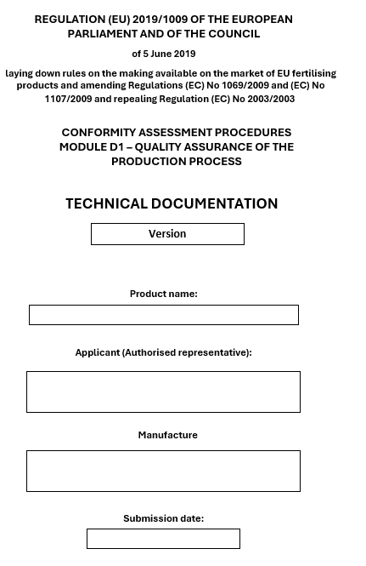

Technical Documentation
According to the (EU) No. 2019/1009 Regulation Annex IV. Part II. Module D1 2.2 the following requirements have to be completed during the type-examination:
The manufacturer shall establish the technical documentation. The technical documentation shall specify the applicable requirements and cover, as far as relevant for the assessment, the design, manufacture, and intended use of the EU fertilising product

(a) General description
General description of the EU fertilising product, the PFC corresponding to the claimed function of the EU fertilising product and description of the intended use.
PFC category:
General description:
Ingredients:
Timing and application rates:
Storage and shelf life:
Potential risk(s) of usage:
The safety data sheet of the product may be likewise provided as a separate file and the file name can be indicated:
product SDS.pdf

(b) List of component materials
A list of component materials used, the CMCs as referred to in Annex II to which they belong, and information about their origin or manufacturing process.
The component materials list must include the component material category (CMC), CAS number, REACH number (if applicable), its origin, and all materials present in the product. This list could be in the form of a table, or other.
Name of the ingredient | CMC category (based on Annex II.) | CAS No. | REACH no. (if applicable / or reason for exemption of reg.) | REACH  Compliance | Origin / manufacturing process
In case of CMC 2: declaration that only the allowed procedures were applied.
A declaration of compliance with this criterion, safety data sheets of all components and regulatory data summaries may be available as a separate file in the documentation. It makes it easier to identify documents if the files are listed here.
- example SDS .pdf
- example SDS2.pdf

(c) The EU declarations of conformity for the component EU fertilising products of the fertilising product blend.
This is required only for PFC 7. The EU declarations of Conformity (EU DoC) template is given in Annex V of the FPR.
The EU DoCmay be provided as separate files:
- example DoC.pdf
- example DoC2.pdf

2. Figure: Template for the EU DoC
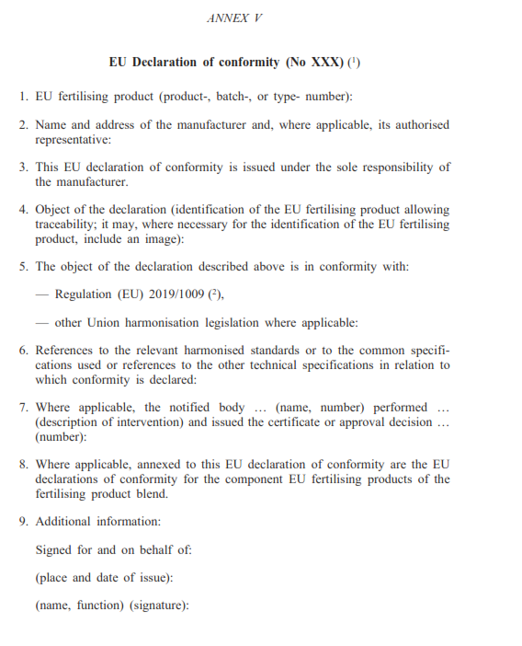

(d) Manufacturing process
Drawings, schemes, descriptions, and explanations necessary for the understanding of the manufacturing process of the EU fertilising product.
A short description of the manufacturing technology or a schematic figure of the manufacturing process has to be attached. It is also essential to highlight all those manufacturing steps (covering in detail the pressure, temperature and duration of the treatments) that could result from either chemical reaction(s) among ingredients or determining into which CMC a component belongs.
For products with materials belonging to CMCs 3, 5, 12, 13, 14 or 15 a written description and a diagram of the production or recovery process, where each treatment, storage vessel, and area is clearly identified.
For products containing or consisting of CMC 13 material, hazardous waste calculations should be included.

(e) Label or leaflet specimen(s)
A specimen of the label or the leaflet, or both, referred to in Article 6(7) containing the information required in accordance with Annex III of (EU) No. 2019/1009 Regulation.
Labels draft or leaflets shall be provided according to the EU document of the visual appearance of the label on EU fertilising products, which is available online:
https://eur-lex.europa.eu/legal-content/EN/TXT/?uri=uriserv:OJ.C_.2021.119.01.0001.01.ENG
The label or leaflet may be provided as separate files:
example label.pdf

(f) A list of the harmonised standards
Please highlight any European and national standards, industry standards or own methods (if any), which have been applied during the design/analysis of the product.
In the event of partly applied harmonised standards or common specifications, clearly state which part was used.
or, if applicable:
A declaration of compliance with this criterion: applied harmonised standards or common specifications are enclosed with the laboratory results.

(g) Results of calculations, examinations carried out, etc
Results of calculations made, including the calculations to demonstrate conformity with point 5 of Part II of Annex I, examinations carried out, etc., if applicable.
Residues of a pharmacologically active substance within the meaning of Regulation (EC) No 470/2009 may be present in an EU fertilising product when its type and volume is accordance with the (EU) No. 2019/1009 Regulation with point 5 of Part II of Annex I. It is mandatory to give detailed information and calculation of the values. If this point does not apply to the EU fertilizer product, the manufacturer shall submit a declaration document regarding this point (g) is not applicable.
Furthermore, any further relevant calculations, that were completed during the design phase of the product, could be also submitted as a part of the Technical Documentation.
For products containing or consisting of CMC10 materials, the TD must include the pesticide residue calculation.
For products containing or consisting of CMC 13 materials, the TD must include the calculation on the removal of the hazardous property during the production process.
The list must include the technical parameters, results and requirements laid down in the Reg. (EU) 2019/1009.
Technical parameter | Results | Requirements laid down in the Reg. (EU) 2019/1009

(h) Test reports
1. General requirements and specific requirements for PFC xx
The results of the calculations made and examinations carried out should be supported by the test reports of the analyses, trials, or reviews carried out on the product and its components to demonstrate conformity with the requirements of Annex I (PFC) and Annex II (CMCs).
If a manufacturer has any own product analysis, or test report(s), it could be also attached to the Technical Documentation.
If the manufacturer has its own laboratory, it will be checked during audits.
For products containing or consisting of CMC 13 materials the test should be done at least every year, or sooner than scheduled in case of any significant change that may affect the safety or quality of the EU fertilising product. For example, processing input material batches of different compositions or modifying process conditions.

Sampling:
- Subsamples taken based on the sampling plan must be mixed and form 4 laboratory samples.
- Notified body’s sample (Please send it to the subcontractor laboratory on behalf of the notified body.),
- Manufacturer’s sample,
- Microbiological sample, if required (5 subsamples are necessary),
- Counter sample (preserving is the responsibility of the manufacturer).
- The sample label includes:
  - sampling date
  - serial number of the sampling protocol
  - sample indication and designation
  - batch number of the item
- The required number of samples and the examined parameters can be found in the FPR regulation.
Analysis
Compositional data | Compositional data.pdf
Heavy metals | Heavy metals.pdf
Pathogens | Pathogens.pdf
Phosphonates | Phosphonates.pdf

2. Biostimulant efficacy evaluation
In the case of biostimulants, the field trial reports shall be included in this point. The CEN/TS 17700-1 harmonised standard can be used to justify biostimulant claims.
(https://shop.standards.ie/en-ie/search/standard/?searchTerm=The%20CEN/TS%2017700-1&productFamily=STANDARD).
Test reports
TR example1.pdf
TR example2.pdf
TR example3.pdf
TR example4.pdf
TR example5.pdf
TR example6.pdf

(i) Animal by-product.
Where the EU fertilising product contains or consists of derived products within the meaning of Regulation (EC) No 1069/2009, the commercial documents or health certificates required pursuant to that Regulation, and evidence that the derived products have reached the end point in the manufacturing chain within the meaning of that Regulation.
If this point does not apply to the EU fertilizer product since it does not contain any animal byproduct. In that case, the manufacturer shall submit a declaration document regarding this point (i) that is not applicable.
If the EU fertilizing products contain or consist of materials (CMC 3, 5, or 10) derived from animal by-products (ABP) within the meaning of Animal By-Product Regulation (EC) No 1069/2009 (ABPR) the following information should be given:
• the commercial documents or health certificates required by the ABPR for the ABPs that are used for the production of OF/SI Regulations (EC 2009/1069 and EU 142/2011),
• and evidence that the derived products have reached the endpoint in the manufacturing chain for OF/SI.

(j) By-products
Where the EU fertilising product contains or consists of by-products within the meaning of Directive 2008/98/EC, technical and administrative evidence that the by-products comply with the criteria established by delegated act referred to in Article 42(7) of this Regulation, and with the national measures transposing Article 5(1) of Directive 2008/98/EC and, where applicable, implementing acts referred to in Article 5(2) or national measures adopted under Article 5(3) of that Directive.
Suppose this point is not applicable to the EU fertilizer product since it does not contain any by-product(s). In that case, the manufacturer shall submit a declaration document regarding this point (j) is not applicable.
Where the EU fertilising product contains or consists of by-products belonging to CMC 11 the following information should be given:
- Technical and administrative evidence that the by-products comply with the criteria of the CMC 11 (as established by delegated REGULATION (EU) 2022/973 of 14 March 2022).
- Demonstration that the material complies with the national measures transposing Article 5(1) of the Waste Framework Directive (WFD) on by-products is not the production of that substance or object is considered not to be waste, but to be a by-product if the following conditions are met:
(a) further use of the substance or object is certain;
(b) the substance or object can be used directly without any further processing other than normal industrial practice;
(c) the substance or object is produced as an integral part of a production process; and
(d) further use is lawful, i.e. the substance or object fulfils all relevant product, environmental and health protection requirements for the specific use and will not lead to overall adverse environmental or human health impacts.
- Where the material in CMC 11 is covered by an EU implementing act or national detailed criteria to define by-product criteria for a certain material this should be stated with reference in the technical documentation.

(k) Total chromium content
Where the EU fertilising product contains total chromium (Cr) above 200 mg/kg, information about the maximum quantity and exact source of total chromium (Cr).
When total chromium content in an EU fertilising product exceeds 200 mg/kg dry matter information a specification of the exact source should be given.
The manufacturer could also submit a declaration document regarding that on the base of the origin of the raw materials and circumstances of technology Cr content above 200 mg/kg can be excluded.
Furthermore, this point can also be proved by laboratory test results.

EU declaration of conformity
Regardless of the chosen conformity assessment the manufacturer shall draw up a written EU declaration of conformity (EU DoC) for an EU fertilising product and keep it together with the technical documentation at the disposal of the national authorities for 5 years after the EU fertilising product has been placed on the market.
The template for the EU DoC is given in Annex V of the FPR. This template must be used to draw up the DoC for fertilising products.
Submission of the DoC draft is a recommendation and is not part of the technical documentation.

